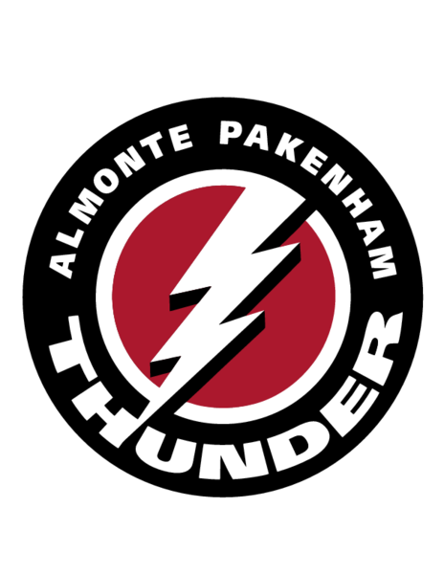
APMHA Publication Policy

Publication and Use of Information Policy
The Almonte Pakenham Minor Hockey Association requires a signed release form from the subject of any photograph, image information or athletic results used for its website or publications. This form must be completed by individuals or parents of individuals to whose photographs, information and athletic results might be posted for publication. The Almonte Pakenham Minor Hockey Association will not publish any image or information of a minor unless his or her parent or legal guardian has signed a permission form.

Photo Release and Consent Form
I hereby grant permission to the Almonte Pakenham Minor Hockey Association to use my image and information for publication without further consideration. Permission is also granted to use images of my child listed below.

I hereby attest that I am the legal parent/guardian of the child listed below. This consent is effective until such time as I revoke it in writing and provide a copy of the revocation to the Almonte Pakenham Minor Hockey Association.

Effective immediately, on the _______ day of _____________________, 20__________.

______________________________________ (Print full legal name of parent or guardian.)

______________________________________ (Legal signature)

______________________________________ (Print full legal name of minor.)

