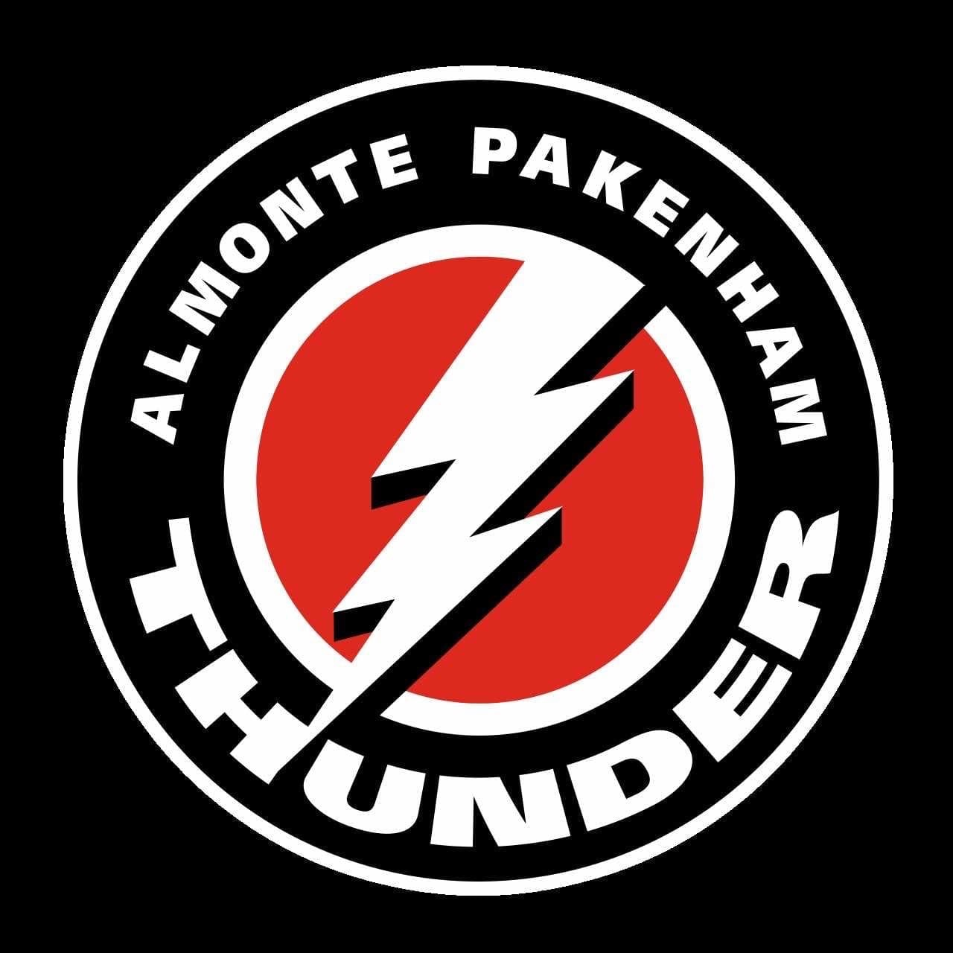APPEAL PROCESS FOR INTERNAL SUSPENSIONS IN BREACH OF THE CODE OF CONDUCT

INTRODUCTION
- This policy, in following the APMHA Code of Conduct Policy, identifies the appeal process for internal association discipline afforded to all Almonte Pakenham Minor Hockey Association (APMHA) members, including but not limited to players, executive members, conveners, coaches, assistant coaches, trainers, managers and any other team officials, on or off-ice game officials, and any other recognized volunteers. It also applies to any individuals who, although not directly employed by, nor a registered member of a team within, nor a volunteer for the APMHA, is considered to have a vested interest in amateur hockey, and/or a strong influence on any of its members; for example, parents/guardians, family members or spectators.

COMPLAINT, INVESTIGATION AND INTERVENTIONS PROCESS
(Taken directly from the Almonte Pakenham Minor Hockey Code of Conduct)

Confidentiality and Neutrality

- The APMHA recognizes the sensitive and serious nature of abuse and harassment, in particular of coming forward with a complaint or of being accused, and will strive to keep all matters related to a complaint confidential. However, if required by law to disclose information, the APMHA will do so.
- The APMHA members receiving complaints shall act with complete neutrality. Just as the complainant has a right to make a complaint, the accused has a right to know that a complaint has been made, and to respond. There are two sides to every story and the first task in sorting out the merits of a complaint is to gather the facts.
- Should a member bring forth a complaint/disclosure describing an issue of abuse or serious harassment, regardless of the scenario or individual’s involved, if the complaint/disclosure is of an abusive or criminal nature, document and report it immediately to your local Child Protection Agency and/or the local Police Detachment, ask for instructions.

Reporting of Complaint/Disclosure
- Any person wanting to file a complaint for follow-up action should report the complaint to the APMHA Director of Discipline and Risk Management and/or President.

- Where a third party person believes there is sufficient evidence to warrant laying a formal complaint, but the victim is apprehensive, unsure or unable to independently bring forth his/her complaint, the third party person, on behalf of the victim, may bring forth the complaint, verbally or in writing.
- Anonymous complaints may be received and mean that there is a possibility that something is wrong and therefore, a discreet investigation is needed. These complaints will be investigated in order to determine if the complaint is founded.
- Upon receipt of a complaint the Director of Discipline and Risk Management will open an investigation into the complaint. All relevant information will be examined and investigated. The result of the investigation will be disclosed to the APMHA President and the information will be held by the APMHA Director of Discipline and Risk Management.
- Only if the complaint is deemed to be founded will the involved parties be notified. If the complaint is concluded to be unfounded, the complainant will be notified of the result and the complaint will be deemed as closed.

Hearing and Sanctions

- A hearing may be required in order to resolve a complaint or to impose sanctions. If a hearing is required, the Director of Discipline and Risk Management will activate a hearing committee composed of the Director of Discipline and Risk Management and two other members of the APMHA Executive.
- The hearing committee will examine the information and evidence of the complaint and listen to the evidence of the involved parties. Written and signed submissions may be considered but given little weight as the hearing committee will not have a chance to discuss the contents with the complainant if they are not present.
- Consequences for a breach of the Code of Conduct can range from a warning to suspension of the member from all activities of the APMHA. The sanction will be decided by the hearing committee and the President advised of the outcome. The result of the hearing will be presented to the APMHA Executive at the following board meeting. The decision will be retained on file by the Director of Discipline and Risk Management for future reference.
- If the complaint requires immediate action the Director of Discipline and Risk Management and/or President may impose an immediate sanction until a hearing can be completed.

APPEAL PROCESS

- Appeals involving internal sanctions should be sent to the Director of Discipline and Risk Management for APMHA.
- Appeals for any sanctioning involving the Almonte Pakenham Minor Hockey Association Code of Conduct shall be made in writing within 72 hours of the sanction being handed down.
- The Director of Discipline and Risk Management will activate a hearing committee composed of the Director of Discipline and Risk Management and two other members of the APMHA Executive.
- The hearing committee will examine the information and evidence of the complaint and listen to the evidence of the involved parties. Written and signed submissions may be considered but given little weight as the hearing committee will not have a chance to discuss the contents with the complainant if they are not present.
- The sanction will be decided by the hearing committee and the President advised of the outcome. The result of the hearing will be presented to the APMHA Executive at the following board meeting. The decision will be retained on file by the Director of Discipline and Risk Management for future reference.
- Appeals of the sanction arising from the Code of Conduct shall be made in writing to District 4 Risk & Safety representative within 72 hours of the sanction being handed down. Appeals of this nature must be forwarded to the District 4 Risk & Safety Representative with the $150 appeal fee.
- Further appeals shall follow the ODMHA Code of Discipline. Section 10.0 Discipline and Appeals.

June 9, 2023

